**Project Planning Phase**

**Project Planning Template (Product Backlog, Sprint Planning, Stories, Story points)**

| Date | 15 February 2025 |
| --- | --- |
| Team ID | SWTID1743511769 |
| Project Name | TravelSphere(Social Media travel enthusiast) |
| Maximum Marks | 5 Marks |

**Product Backlog, Sprint Schedule, and Estimation (4 Marks)**

Use the below template to create product backlog and sprint schedule

| **Sprint** | **Functional Requirement (Epic)** | **User Story Number** | **User Story / Task** | **Story Points** | **Priority** | **Team Members** |
| --- | --- | --- | --- | --- | --- | --- |
| Sprint-1 | Registration | USN-1 | As a user, I can register for the application by entering my email, password, and confirming my password. | 2 | High | Shreya |
| Sprint-1 | Registration | USN-2 | As a user, I will receive confirmation email once I have registered for the application | 1 | High | Sristi |
| Sprint-2 | Registration | USN-3 | As a user, I can register for the application through Facebook | 2 | Low | Parth |
| Sprint-1 | Registration | USN-4 | As a user, I can register for the application through Gmail | 2 | Medium | Shivang |
| Sprint-1 | Login | USN-5 | As a user, I can log into the application by entering email & password | 1 | High | Shreya |
| Sprint-2 | Dashboard | USN-6 | As a user, I can view my personal dashboard after login. | 3 | High | Shivang |
| Sprint-2 | Dashboard | USN-7 | As a user, I can see project recommendations on my dashboard. | 3 | Medium | Parth |
| Sprint-3 | Dashboard | USN-8 | As a user, I can edit my profile information from the dashboard. | 3 | Medium | Shreya |
| Sprint-3 | Tracker | USN-9 | As a user, I can track project progress visually. | 4 | High | Parth |
| Sprint-4 | Tracker | USN-10 | As a user, I can view upcoming tasks and deadlines. | 4 | High | Shreya |

**Project Tracker, Velocity & Burndown Chart: (4 Marks)**

| **Sprint** | **Total Story Points** | **Duration** | **Sprint Start Date** | **Sprint End Date (Planned)** | **Story Points Completed (as on Planned End Date)** | **Sprint Release Date (Actual)** |
| --- | --- | --- | --- | --- | --- | --- |
| Sprint-1 | 6 | 5 Days | 23 March 2025 | 29 March 2025 | 6 | 29 March 2025 |
| Sprint-2 | 8 | 5 Days | 29 March 2025 | 2 April 2025 | 8 | 2 April 2025 |
| Sprint-3 | 7 | 5 Days | 2 April 2025 | 7 April 2025 | TBD | 7 April 2025 |
| Sprint-4 | 8 | 5 Days | 7 April 2025 | 9 April 2025 | TBD | 9 April 2025 |

**Velocity:**

Imagine we have a 10-day sprint duration, and the velocity of the team is 20 (points per sprint). Let’s calculate the team’s average velocity (AV) per iteration unit (story points per day)

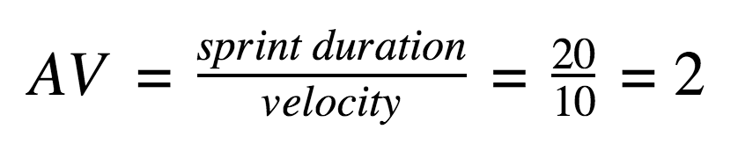

**Story Points Completed (Sprint-1 + Sprint-2)** = 6 + 8 = **14**

**No. of Sprints** = 2

Velocity=2/14​=7 Story Points per Sprint

**Burndown Chart Table Data:**

A burn down chart is a graphical representation of work left to do versus time. It is often used in agile[software development](https://www.visual-paradigm.com/scrum/what-is-agile-software-development/) methodologies such as [Scrum](https://www.visual-paradigm.com/scrum/scrum-in-3-minutes/). However, burn down charts can be applied to any project containing measurable progress over time.

| Day | Planned Remaining Work | Actual Remaining Work |
| --- | --- | --- |
| Day 0 | 29 SP | 29 SP |
| Day 1 | 25 SP | 27 SP |
| Day 2 | 21 SP | 24 SP |
| Day 3 | 17 SP | 20 SP |
| Day 4 | 13 SP | 17 SP |
| Day 5 | 9 SP | 13 SP |
| Day 6 | 5 SP | 8 SP |
| Day 7 | 0 SP | 6 SP (Backlogs carried) |